IC TRAINING CENTER VIET NAM
FUNDAMENTAL IC DESIGN AND VERIFICATION COURSE


FINAL PROJECT
TIMER IP DESIGN SPECIFICATION

Student: Thong Nguyen
Class: IC39
Instructor: Tri Le

Contents
LIST OF TABLES 3
LIST OF FIGURES 3
1.Overview 4
1.1. Introduction 4
1.2. Main features 4
1.3. Block diagram 6
1.4. Interface signals 7
2.Register Specification 8
2.1. Register Summary 8
2.2. Timer Control Register (TCR) 8
2.3. Timer Data Register 0 (TDR 0) 10
2.4. Timer Data Register 1 (TDR 1) 10
2.5. Timer Compare Register 0 (TCMP 0) 11
2.6. Timer Compare Register 1 (TCMP 1) 11
2.7. Timer Interrupt Enable Register (TIER) 12
2.8. Timer Interrupt Status Register (TISR) 13
2.9. Timer Halt Control Status Register (THCSR) 14
3. Functional Description 15
3.1. APB slave 15
3.2. Register 17
3.2.1TCR 17
3.2.3 TDR0 and TDR1 18
3.2.4 TCMP0 and TCMP1 19
3.2.5TISR 19
3.2.6TIER 20
3.2.7THCSR 21
3.3.6 Read data circuit 22
3.3. Count control 22
3.4. Counter 23
3.5.Interrupt Control 24
4. History 25

LIST OF TABLES
Table 1: Interface signals of timer IP 7
Table 2: Register Summary 9
Table 3. Timer Control Register (TCR) 10
Table 4. Timer Data Register 0 (TDR0) 11
Table 5. Timer Data Register 1 (TDR1) 12
Table 6. Timer Compare Register 0 (TDR0) 12
Table 7. Timer Compare Register 1 (TCMP1) 13
Table 8. Timer Interrupt Enable Register (TIER) 13
Table 9. Timer Interrupt Status Register (TISR) 14
Table 10. Timer Halt Control Status Register (THCSR) 15
Table 11. Update history 27

LIST OF FIGURES
Figure 1: Block diagram of IP 6
Figure 2: Write access with wait state 16
Figure 3: Schematic for APB module 17
Figure 4: Schematic of TCR 19
Figure 5: Schematic of TDR0/1 20
Figure 6: Schematic of TCMP0/1 21
Figure 7: Schematic of TISR 22
Figure 8: Schematic of TIER 22
Figure 9: Schematic of THCSR 23
Figure 10: Schematic of read data circuit 24
Figure 11: Schematic of Count Control module 24
Figure 12: Example waveform of different count speed 25
Figure 13: Schematic of Adder module 26
Figure 14: Schematic of Interrupt Control 26

1.Overview

1.1. Introduction
Timers are an essential module of every chip, they are used to generate accurate timing intervals or control the timing of various operations within the circuit. Timer can be used in various applications: pulse generation, delay generation, event generation, PWM generation, Interrupt generation ….
This timer module is customized from the CLINT module of industrial RISC-V architecture. It is used to generate interrupt based on users’ settings

1.2. Main features
- 64-bit count up
- 12-bit address
- Register set is configured via APB bus (IP is APB slave).
- Support wait state (1 cycle is enough) and error handling
- Support byte access o Support halt (stop) in debug mode
- Timer uses active low async reset.
- Counter can be counted based on the system clock or divided up to 256.
- Support timer interrupt (can be enabled or disabled).
Figure 1: block diagram of Timer IP

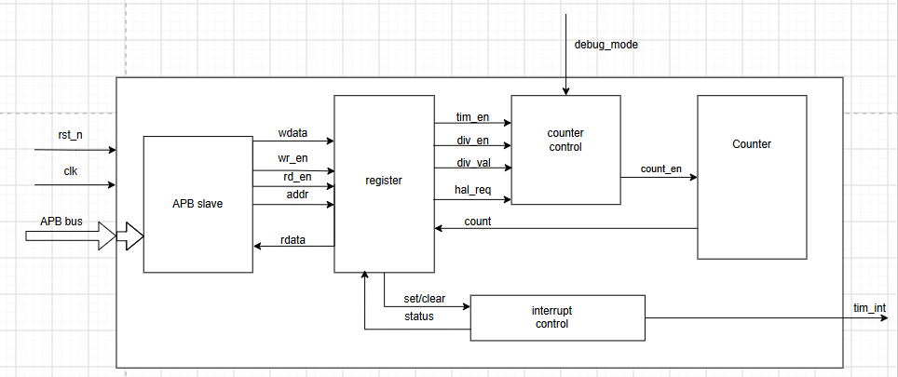
1.3. Block diagram
Figure 1: Block diagram of IP
APB slave
This sub-block processes the data from the APB bus in transfer between APB master and the IP’s register in read and write access to the register.

Register
This sub-block stores data of the IP, including interrupt data, counting data, and data that is written from APB bus

Counter control
Control between different counting speed, process data from register to configure counting speed of the IP, control between different counting modes.

Interrupt control
This sub-block control interrupt data and send to output of the IP and to the register.

Counter
This sub-block is the counter of the IP, which increments the count data and send back to the register.

1.4. Interface signals
Table 1: Interface signals of timer IP
Signal name | Width | Direction | Description
sys_clk | 1 | Input | Clock.  sys_clk is a clock signal. All APB signals are timed against the rising edge of sys_clk.
sys_rst_n | 1 | Input | Reset.  sys_rst_n is the reset signal and is active-LOW. sys_rst_n is normally connected directly to the system bus reset signal
tim_psel | 1 | Input | Select.  The Requester generates a tim_psel signal for each Completer. tim_psel indicates that the Completer is selected and that a data transfer is required.
tim_pwrite | 1 | Input | Direction.  tim_pwrite indicates an APB write access when HIGH and an APB read access when LOW.
tim_penable | 1 | Input | Enable.  tim_penable indicates the second and subsequent cycles of an APB transfer
tim_paddr[11:0] | 12 | Input | Address.  tim_paddr is the APB address bus.
tim_pwdata[31:0] | 32 | Input | Write data.  The tim_pwdata write data bus is driven by the APB bridge Requester during write cycles when tim_pwrite is HIGH.
tim_prdata[31:0] | 32 | Output | Read data.  The tim_prdata read data bus is driven by the selected Completer during read cycles when PWRITE is LOW.
tim_pstrb[3:0] | 4 | Input | Write strobe.  tim_pstrb indicates which byte lanes to update during a write transfer. There is one write strobe for each 8 bits of the write data bus. tim_pstrb[n] corresponds to tim_pwdata[(8n + 7):(8n)]. tim_pstrb must not be active during a read transfer.
tim_pready | 1 | Output | Ready.  tim_pready is used to extend an APB transfer by the Completer.
tim_pslverr | 1 | Output | Transfer error.  tim_pslverr is an optional signal that can be asserted HIGH by the Completer to indicate an error condition on an APB transfer.
tim_int | 1 | Output | Interrupt.  tim_int is the output signal that flags HIGH by the Completer when the interrupt conditions is met.
dbg_mode | 1 | Input | Debug.  dgb_mode is an input signal that can be asserted HIGH by the Requester when the user want to turn on halt mode.

2.Register Specification

2.1. Register Summary
Table 2: Register Summary
Offset | Abbreviation | Register name
0x00 | TCR | Timer Control Register
0x04 | TDR0 | Timer Data Register 0
0x08 | TDR1 | Timer Data Register 1
0x0C | TCMP0 | Timer Compare Register 0
0x10 | TCMP1 | Timer Compare Register 1
0x14 | TIER | Timer Interrupt Enable Register
0x18 | TISR | Timer Interrupt Status Register
0x1C | THCSR | Timer Halt Control Status Register
Others | Reserved

2.2. Timer Control Register (TCR)
Offset address: 0x0
Reset value: 0x0000_0100
31 | 30 | 29 | 28 | 27 | 26 | 25 | 24 | 23 | 22 | 21 | 20 | 19 | 18 | 17 | 16
Reserved

15 | 14 | 13 | 12 | 11 | 10 | 9 | 8 | 7 | 6 | 5 | 4 | 3 | 2 | 1 | 0
Reserved |  |  |  | DIV_VAL[3:0] |  |  |  | Reserved |  |  |  |  |  | DIV_  EN | TIM_  EN
 |  |  |  | rw |  |  |  |  |  |  |  |  |  | rw | rw

Table 3. Timer Control Register (TCR)
Bit | Name | Type | Default value | Description
31:12 | Reserved | - | 20’h0 | Reserved
11:8 | DIV_VAL[3:0] | RW | 4’b0001 | Counter control mode setting:  - 4’b0000: Counting speed is not divided  - 4’b0001: Counting speed is divided by 2 (default)  - 4’b0010: Counting speed is divided by 4  - 4’b0011: Counting speed is divided by 8  - 4’b0100: Counting speed is divided by 16  - 4’b0101: Counting speed is divided by 32  - 4’b0110: Counting speed is divided by 64  - 4’b0111: Counting speed is divided by 128  - 4’b1000: Counting speed is divided by 256  - Others: reserved (*)prohibit settings. When setting the prohibited value, div_val is not changed.  Note: user must not change div_val while timer_en is High  (*): div_val is prohibited to change when timer_en is High. Access is an error response in this case.  (*)Access is “error response” when setting prohibit value to div_val
7:2 | Reserved | RO | 6’b0 | Reserved
1 | DIV_EN | RW | 1’b0 | Counter control mode enabling.  - 0: Disabled. Counter counts with normal speed based on system clock  - 1: Enabled. The counting speed of counter is controlled based on div_val  Note: user must not change div_en while timer_en is High  div_en is prohibited to change when timer_en is High. Access is error response in this case.
0 | TIM_EN | RW | 1’b0 | Timer enable  - 0: Disabled. Counter does not count.  - 1: Enabled. Counter starts count  Timer from High to Low will initialize TDR0/1 to their initial value

2.3. Timer Data Register 0 (TDR 0)
Offset address: 0x4
Reset value: 0x0000_0000
31 | 30 | 29 | 28 | 27 | 26 | 25 | 24 | 23 | 22 | 21 | 20 | 19 | 18 | 17 | 16
TDR 0
rw

15 | 14 | 13 | 12 | 11 | 10 | 9 | 8 | 7 | 6 | 5 | 4 | 3 | 2 | 1 | 0
TDR 0
rw

Table 4. Timer Data Register 0 (TDR0)
Bit | Name | Type | Default value | Description
31:0 | TDR0 | RW | 32’h0 | Lower 32-bit of the 64-bit counter.  Value of this register is cleared to initial value when timer_en changes from High to Low

2.4. Timer Data Register 1 (TDR 1)
Offset address: 0x8
Reset value: 0x0000_0000
31 | 30 | 29 | 28 | 27 | 26 | 25 | 24 | 23 | 22 | 21 | 20 | 19 | 18 | 17 | 16
TDR 1
rw

15 | 14 | 13 | 12 | 11 | 10 | 9 | 8 | 7 | 6 | 5 | 4 | 3 | 2 | 1 | 0
TDR 1
rw

Table 5. Timer Data Register 1 (TDR1)
Bit | Name | Type | Default value | Description
31:0 | TDR0 | RW | 32’h0 | Upper 32-bit of the 64-bit counter.  Value of this register is cleared to initial value when timer_en changes from High to Low

2.5. Timer Compare Register 0 (TCMP 0)
Offset address: 0x0C
Reset value: 32’hFFFF_FFFF
31 | 30 | 29 | 28 | 27 | 26 | 25 | 24 | 23 | 22 | 21 | 20 | 19 | 18 | 17 | 16
TCMP 0
rw

15 | 14 | 13 | 12 | 11 | 10 | 9 | 8 | 7 | 6 | 5 | 4 | 3 | 2 | 1 | 0
TCMP 0
rw

Table 6. Timer Compare Register 0 (TDR0)
Bit | Name | Type | Default value | Description
31:0 | TCMP0 | RW | 32’hFFFF_FFFF | Lower 32-bit of the 64-bit compare value.  Interrupt pending bit is asserted when counter value is equal to compare value.

2.6. Timer Compare Register 1 (TCMP 1)
Offset address: 0x10
Reset value: 32’hFFFF_FFFF

31 | 30 | 29 | 28 | 27 | 26 | 25 | 24 | 23 | 22 | 21 | 20 | 19 | 18 | 17 | 16
TCMP 1
rw

15 | 14 | 13 | 12 | 11 | 10 | 9 | 8 | 7 | 6 | 5 | 4 | 3 | 2 | 1 | 0
TCMP 1
rw

Table 7. Timer Compare Register 1 (TCMP1)
Bit | Name | Type | Default value | Description
31:0 | TCMP1 | RW | 32’hFFFF_FFFF | Upper 32-bit of the 64-bit compare value.  Interrupt pending bit is asserted when counter value is equal to compare value.

2.7. Timer Interrupt Enable Register (TIER)
Offset address: 0x14
Reset value: 32’h0
31 | 30 | 29 | 28 | 27 | 26 | 25 | 24 | 23 | 22 | 21 | 20 | 19 | 18 | 17 | 16
Reserved

15 | 14 | 13 | 12 | 11 | 10 | 9 | 8 | 7 | 6 | 5 | 4 | 3 | 2 | 1 | 0
Reserved |  |  |  |  |  |  |  |  |  |  |  |  |  |  | int_en

Table 8. Timer Interrupt Enable Register (TIER)
Bit | Name | Type | Default value | Description
31:1 | Reserved | - | 31’h0 | Reserved
0 | INT_EN | RW | 1’b0 | Timer interrupt enable  - 0: Timer interrupt is disabled.  - 1: Timer interrupt is enabled.  When this bit is 0, no timer interrupt is output. When this bit is 1, timer interrupt pending bit can be output (interrupt pending bit is set when counter value is equals to compare value).  Clearing this bit to 0 while interrupt is asserting will mask the interrupt to 0 but does not affect the interrupt pending bit (TISR.int_st bit).

2.8. Timer Interrupt Status Register (TISR)
Offset address: 0x18
Reset value: 32’h0
31 | 30 | 29 | 28 | 27 | 26 | 25 | 24 | 23 | 22 | 21 | 20 | 19 | 18 | 17 | 16
Reserved

15 | 14 | 13 | 12 | 11 | 10 | 9 | 8 | 7 | 6 | 5 | 4 | 3 | 2 | 1 | 0
Reserved |  |  |  |  |  |  |  |  |  |  |  |  |  |  | int_st
 |  |  |  |  |  |  |  |  |  |  |  |  |  |  | rw1c

Table 9. Timer Interrupt Status Register (TISR)
Bit | Name | Type | Default value | Description
31:1 | Reserved | - | 31’h0 | Reserved
0 | INT_ST | RW1C | 1’b0 | Timer interrupt trigger condition status bit (interrupt pending bit)  - 0: the interrupt trigger condition does not occur.  - 1: the interrupt trigger condition occurred.  Write 1 when this bit is 1 to clear it to 0.  Write 0 when this bit is 1 has no effect.  Write to this bit when it is 0 has no effect.  Note1: When the interrupt trigger condition occurs (counter reached compare value), counter continues to count normally.  Note2: the clearance condition has the highest priority.

2.9. Timer Halt Control Status Register (THCSR)
Offset address: 0x1C
Reset value: 32’h0
31 | 30 | 29 | 28 | 27 | 26 | 25 | 24 | 23 | 22 | 21 | 20 | 19 | 18 | 17 | 16
Reserved

15 | 14 | 13 | 12 | 11 | 10 | 9 | 8 | 7 | 6 | 5 | 4 | 3 | 2 | 1 | 0
Reserved |  |  |  |  |  |  |  |  |  |  |  |  |  | halt_ack | halt_req
 |  |  |  |  |  |  |  |  |  |  |  |  |  | ro | rw

Table 10. Timer Halt Control Status Register (THCSR)
Bit | Name | Type | Default value | Description
31:2 | Reserved | - | 3’h0 | Reserved
1 | HALT_ACK | RO | 1’b0 | Timer halt acknowledge  - 0: timer is NOT halted  - 1: timer is halted 1’b0  Timer accepts the halt request only in debug mode, indicates by debug_mode input signal
0 | HALT_REQ | RW |  | Timer halt request 0: no halt req. 1: timer is requested to halt.

3. Functional Description

3.1. APB slave
The timer uses an APB slave to receive data from the user to configure the timer. The user can write data to the timer’s register to turn on and off the timer or setting the counting speed, and the compare threshold for the timer.
Features of APB slave
- 12-bit width address
- 32-bit width read/write data
- Support wait state and error response

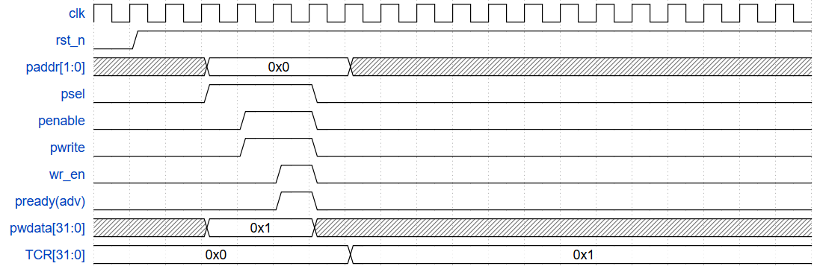
Figure 2: Write access with wait state
The APB protocol takes at least 2 clock cycles to write data into the IP’s register
- In the first cycle - the SET UP state, PENABLE set low, PSEL is set high, PADDR and PDATA is set
- In the second cycle, PENABLE and PWRITE are set high. From this cycle, the APB master waits for the high PREADY from the IP’s APB slave. When PREADY is high, wr_en is set high, data is transferred to the register, and the data transmission ends
- In this case, the wait state is 1 clock cycle; thus in the third clock cycle, PREADY is set high, wr_en is set high
- After the third clock cycle, PSEL is set low while other signals are “don’t care”, marking the end of one data transmission

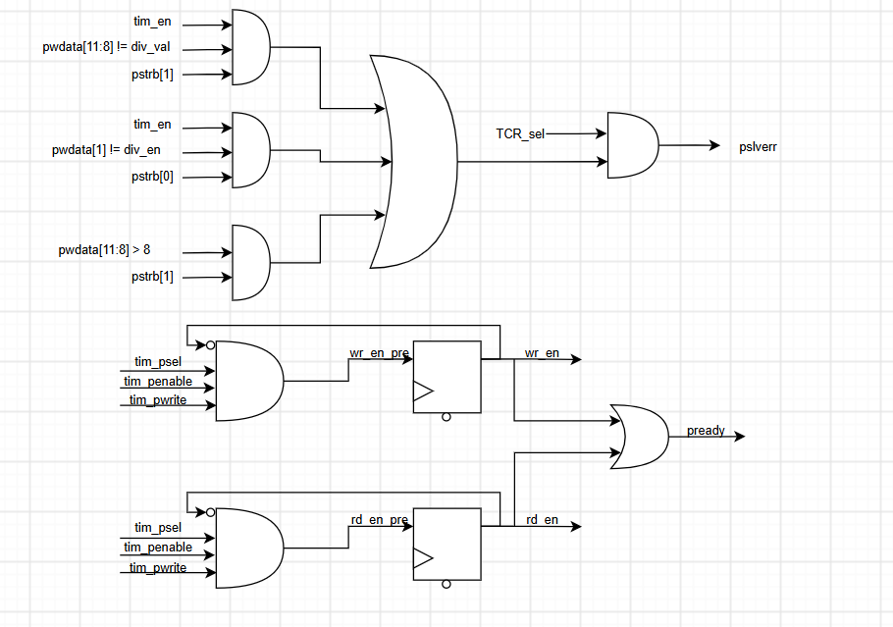
Figure 3: Schematic for APB module
- wr_en is the signal sent to the register module, when wr_en is High, data is written to the register. wr_en is created as an AND of the three signals PSEL, PENABLE, PWRITE, which indicates the ACCESS state of APB interface.
- rd_en is the signal sent to the register module, when rd_en is High, data is read from the register. rd_en is created as an AND of the three signals PSEL, PENABLE, PWRITE, which indicates the ACCESS state of the APB interface.
- The registers are used to delay 1 clock cycle for the wait state so that wr_en or rd_en and PREADY it set high 1 cycle after PENABLE and PWRITE is set high
- PREADY is the OR of wr_en and rd_en because PREADY is set high in the ACCESS state

Error response:
- Whenever an error happen in a write access, APB slave raise the PSLVERR signal and preventing new invalid data be written into the register
- Error response in APB signal is returned whenever one of the three cases happen:
  - Changing the value of div_val while counting
  - Changing the value of div_en while counting
  - Changing the value of div_val to prohibited value
Partial Data Transfer
- The APB slave supports partial data transfer, allowing users to write into each byte of the 32-bit registers

3.2. Register

3.2.1TCR

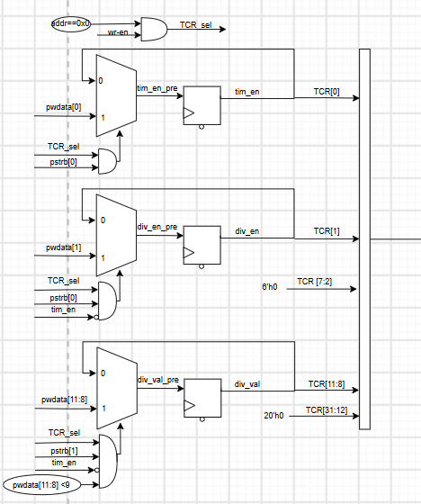
Figure 4: Schematic of TCR

TCR is where the configuration of the timer is saved
- tim_en turns the counter on or off
- div_en decides the counting mode of the timer
- div_val decides the counting speed of the timer

Error response
- div_val only accepts certain values written into the register. If any invalid div_val value is written into the register, the register stays the same and keeps the previous value.
- div_en and div_val can only be written to when the timer is off. When data is written to div_en and div_val, the IP raises PSLVERR signal and keeps the previous data in the register.

3.2.3 TDR0 and TDR1

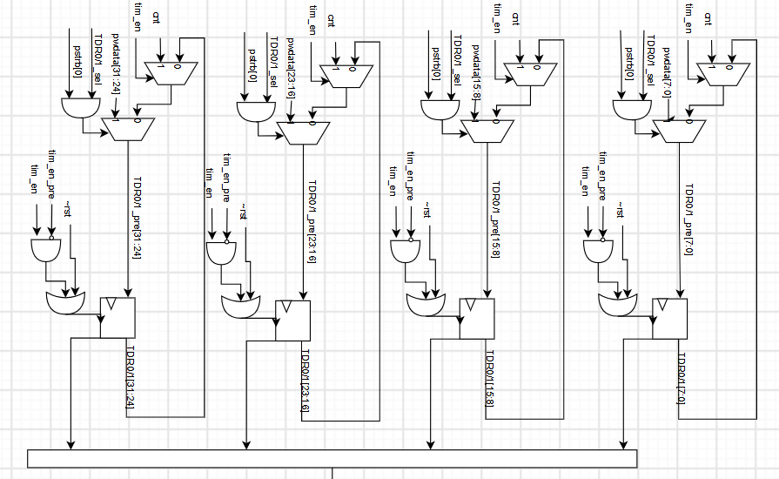
Figure 5: Schematic of TDR0/1

- User can write into this register to configure starting point of counting
- The counter take value from TDR0 and TDR1 to count up
- After each increment, the counter save the new value back to TDR0 and TDR1
- TDR0 and TDR1 are reset to default value when the timer is turned off

3.2.4 TCMP0 and TCMP1

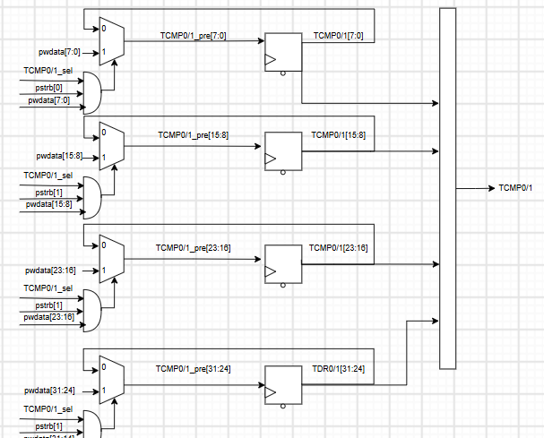
Figure 6: Schematic of TCMP0/1
- Store the threshold value that the IP compares the count value in TDR to
- User can write into this register to configure the interrupt threshold of the IP

3.2.5TISR
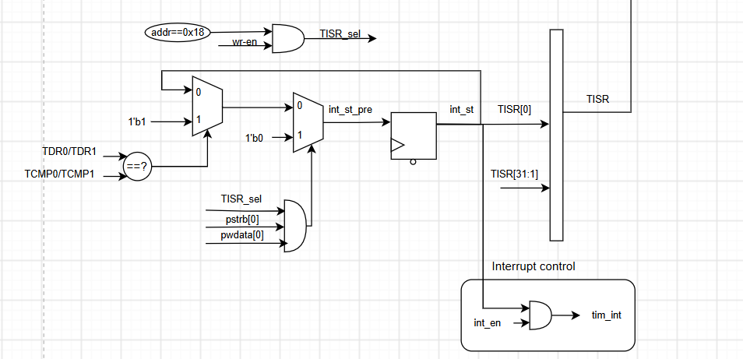
Figure 7: Schematic of TISR
TISR is where the timer save interrupt status from the interrupt controller
- Whenever TDR0 = TCMP0 and TDR1 = TCMP1, tim_int is set pending high and the status is saved to the TISR.tim_st
- tim_st is only reset when 1 is written to the bit.
- Write 0 will not have any affect on int_st
- Write 1 to int_st when the status is 0 will not change the data in the register
- The reset function have the highest priority

3.2.6TIER

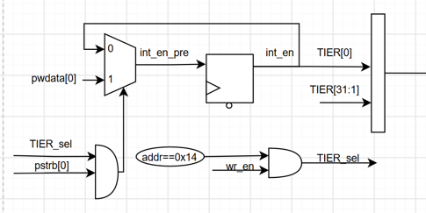
Figure 8: Schematic of TIER

- TIER.int_en is the mask for tim_int signal output from the IP.
- tim_int is set pending high when TDR0 = TCMP0 and TDR1 = TCMP1. When this happens, if
- int_en = 1, tim_int = 1
- int_en = 0, tim_int = 0

3.2.7THCSR
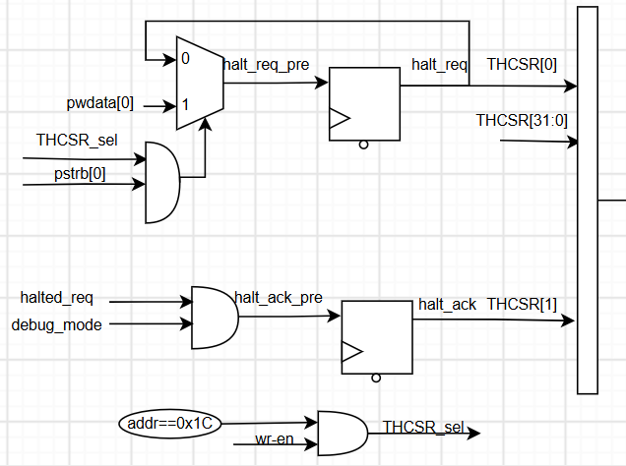
Figure 9: Schematic of THCSR

- Halt_reg is set by writing into THCSR to request for halting.
- Halting only happens when the IP’s input dbg_mode is set.
- When halting happens, halt_ack is set.

3.3.6 Read data circuit

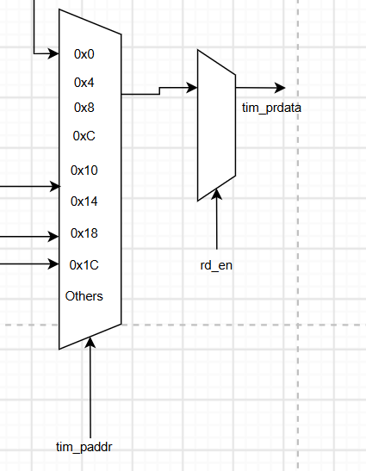
Figure 10: Schematic of read data circuit
- Which register is being read is decided by a mux with 9 inputs. Which input is connected to output is determined by the address input from APB slave.

3.3. Count control

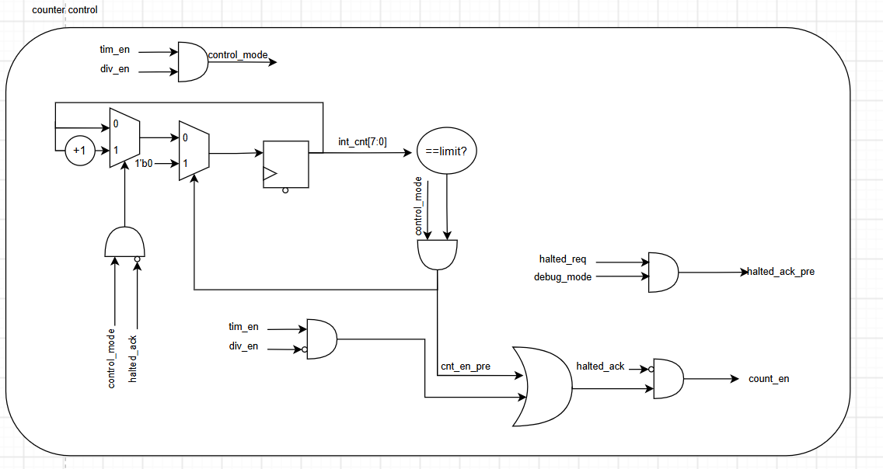
Figure 11: Schematic of Count Control module
Functionality
- To control the counting speed, the IP’s counter control have an internal counter which decides how many cycles does it take for a the IP’s clock to increment by 1
When TCR.div_en is 1
- This internal counter counts to a limit determined by TCR.div_val. When the limit is reached, the counter control submodule send a count_en pulse to the IP’s counter which increments the counter by 1
- The counting function of the internal counter is controlled by THCSR.halt_ack, when the IP is halted, the internal counter stops counting but does not reset. Thus, when halting is stopped, the internal counter continues to count from its current value, maintaining the counting process normally
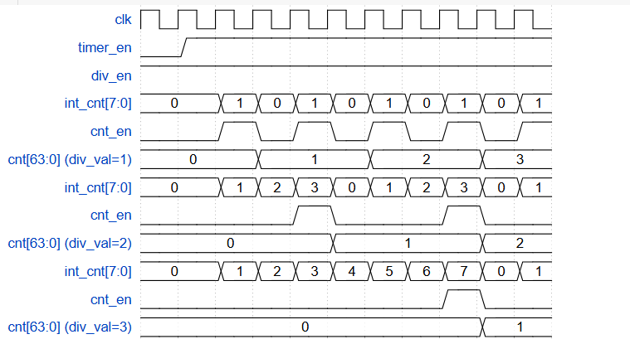
Figure 12: Example waveform of different count speed
When TCR.div_en is 0
- count_en is connected to tim_en; thus whenever the timer is on, the counter control will send a 1 signal to the counter, making it count up every clock cycle.

3.4. Counter
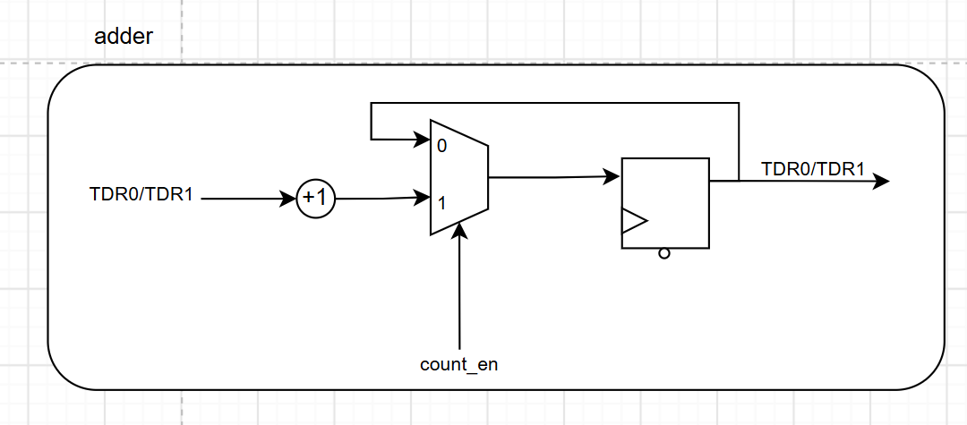
Figure 13: Schematic of Adder module
- The counter takes value from TDR0 and TDR1, when the signal count_en from the count control submodule is 1, the counter increments the count value by 1 and writes back to TDR0 and TDR1.

3.5.Interrupt Control
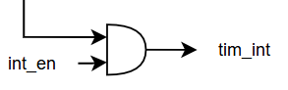
Figure 14: Schematic of Interrupt Control
- This sub-module masks the interrupt status with interrupt enable value from the TIER register to control if the interrupt signal is sent

4. History
Table 11. Update history
Date | Version | Description | Author
19/8/2026 | 1.0 | Newly created | Thong Nguyen
4/9/2026 | 1.1 | First fully finishes version | Thong Nguyen
19/9/2026 | 1.2 | Minor updates on formating | Thong Nguyen

